

SECTION 26 09 43
  - Network Lighting Controls
Specifier: The Specifier/Design Professional is responsible for the accuracy of all project specifications, including system application and coordination with related sections. This guide specification is provided as a convenience and requires editing to match actual project requirements. CRESTRON ELECTRONICS, INC. SHALL NOT BE LIABLE FOR ANY DAMAGES ARISING OUT OF THE USE OF ANY OF ITS GUIDE SPECIFICATIONS. For Crestron design assistance and design review please contact Crestron Design at 888-330-1502 or clcdesign@crestron.com
To remove photos from printing: File->Options->Display then uncheck the “Print Drawings created in Word”

GENERAL

SUMMARY

Section Includes:

Networked Central Lighting Control systems. Systems are composed of:

Network integrated power switching systems.

Network integrated dimming systems.

Standalone power switching and dimming systems.

DALI-compliant network integrated lighting controller.

Automation control processors.

Sensors

User Interfaces:

Keypad

Touch screen

Virtual touch screen

System Functions and Sequences

Related Requirements:

Section 12 24 13 Roller Window Shades

Section 25 08 00 Commissioning of Integrated Automation

Section 25 10 00 Integrated Automation Network Equipment

Section 25 11 13 Integrated Automation Network Servers

Section 25 13 13 Integrated Automation Control and Monitoring Network Supervisory Control

Section 25 13 19 Integrated Automation Control and Monitoring Network Interoperability

Section 25 15 16 Integrated Automation Software for Control and Monitoring Networks

Section 26 05 00 Common Work Results For Electrical

Section 26 27 26 Wiring Devices

Section 26 51 00 Interior Lighting

Section 27 15 00 Communications Horizontal Cabling

Section 27 41 00 Audio-Video Systems

REFERENCES

Definitions

Control: Effecting a change in state by one PC program onto a microprocessor or device.

Scene: Predetermined light level of a single fixture of group of fixtures.

DALI: Digital addressable lighting interface.

RS-485: A serial network protocol complying with TIA-485-A.

UTP: Unshielded twisted pair.

Reference Standards

California Energy Commission (CEC):

CEC CCR Title 24, Part 6: California Energy Efficiency Standards for Residential and Nonresidential Buildings, California's Appliance Efficiency Program: Listed lighting control devices.

National Fire Protection Association (NFPA):

NFPA 70 - National Electrical Code.

Underwriters Laboratories (UL)

UL 508 – Industrial Control Equipment

SYSTEM DESCRIPTION

Web Accessible, network connected, lighting control system utilizing preset control software, central signal microprocessor, lighting control panel including integrated branch circuit protection, and [power switching modules and relays] [Dimming Modules] [DALI Control Modules] [Sensors] [User Interfaces].

System Components: System includes the following addressable components:

Keypad controls.

Touch screen controls.

Window treatment controls.

Remote occupancy sensors.

Lighting load shedding.

Timed room lighting.

Daylight compensating lighting controls.

Communication interface to facility-wide room management system.

Communication interface to building automation system gateway/interface.

SUBMITTALS

Product Data: For each type of product required for complete network lighting control system, demonstrating compliance with requirements.

Shop Drawings: Indicated the following:

Schematic diagram showing complete network lighting control system and accessories.

Circuits and emergency circuits with capacity and phase, control zones, load type and voltage per circuit.

CLOSEOUT SUBMITTALS

Operating and maintenance instructions.

QUALITY ASSURANCE

Manufacturer Qualification: Manufacturer of network lighting controls with minimum [five] years record of satisfactory manufacturing and support of components comparable to basis of design system.

Source Requirements: Provide Network Lighting System through a single source from a single manufacturer.

Manufacturer Qualifications: Approved manufacturer of network lighting controls listed in this Section with minimum [five] years record of satisfactory manufacturing and support of components comparable to basis of design system.

Approval of Comparable Products: Submit the following in accordance with project substitution requirements, within time allowed for substitution review:

Product data, including certified independent test data indicating compliance with requirements.

Samples of each component.

Sample submittal from similar project.

Project references: Minimum of 5 installations not less than 5 years old, with Owner and Architect contact information.

Sample warranty.

Substitutions following award of contract are not allowed except as stipulated in Division 01 General Requirements.

Approved manufacturers must comply with separate requirements of Submittals Article.

Electrical Components, Devices, and Accessories: UL listed and labeled per NFPA 70.

California Appliance Efficiency Listing: Provide products that comply with provisions of CEC CCR Title 24, Part 6.

COORDINATION

Coordinate integrated lighting and dimming controls with systems and components specified in the following sections:

Division 11 Section "Audio-Visual Equipment".

Division 12 Section "Window Treatments".

Division 23 Section "Instrumentation and Control for HVAC".

Division 25 Section "Integrated Automation Control of Electrical Systems".

Division 26 Section "Panelboards".

Division 26 Section "Wiring Devices".

Division 26 Section "Lighting Devices".

Division 26 Section "Interior Lighting".

Division 27 Section "Communications Horizontal Cabling".

Division 27 Section “Audio-Video Systems”

Division 28 Section "Electronic Access Control and Intrusion Detection".

PROJECT CONDITIONS

Environmental Conditions Range:

Temperature: 32 – 104 deg F (0 - 40 deg C).

Relative Humidity: 10 – 90 percent, noncondensing.

WARRANTY

Special Warranty: Manufacturer's standard form in which manufacturer agrees to repair or replace components of modular dimming controls system the fail in materials or workmanship within the specified warranty period following substantial completion.

Warranty Period: Touch screen display and overlay components: 90 days.

Warranty Period: Disc drives and other moving parts, pan/tilt heads, and power supplies: 1 year.

Warranty Period: Other components, up to 8 years as per warranty contract.

Manufacturer's Extended Support Service: Extended telephone support: Unlimited period.

PRODUCTS

WIRELESS DIMMING SOLUTIONS

MANUFACTURERS

Basis-of-Design Manufacturer: Subject to compliance with requirements, provide products of Crestron Electronics, Inc., Rockleigh, NJ 07647, Phone (855) 644-7643, www.crestron.com [or comparable products from a single manufacturer approved by Architect prior to bidding], with the following components and characteristics.

Wireless technology shall be fully compatible and scalable with all manufacturer lighting control solutions.

All batteries shall be field replaceable with non-proprietary standard sizes.

WIRELESS DEVICES WITHIN THE SPACE

Lighting control devices within the space shall communicate using a Wi-Fi friendly 2.4 GHz peer-to-peer mesh network topology. Devices within the space shall be commissionable as an autonomous control system without the need for additional equipment. Each device shall auto negotiate its RF channel to avoid noisy commercial environments. Wireless communication shall be secured using 128-bit encryption. Up to 32 devices can make up a space. The range between wireless devices shall be 50’. The wireless technology shall be Crestron Zūm MESH.

Junction Box Zone Controllers

Zūm MESH wireless communication

Junction box mounted using ½” knockout

120 / 277 VAC input

Product

Crestron ZUMMESH-JBOX-16A-SW (switched load, 16 amps)

Crestron ZUMMESH-JBOX-5A-LV (0-10v dimmed load, 5 amps)

Crestron ZUMMESH-JBOX-16A-LV (0-10v dimmed load, 16 amps)

Crestron ZUMMESH-JBOX-20A-PLUG (switched plug load, 20 amps)

Wall Box Zone Controllers

Zūm MESH wireless communication

Trimmed using gangable Decorator trim plates

Mounted in 3.5” back box

Color shall be white [black] [almond]

Product

Crestron ZUMMESH-5A-SW-W [B] [A]-S (switched load, 5 amps)

Crestron ZUMMESH-5A-LV-W [B] [A]-S (0-10v dimmed load, 5 amps)

Keypads (Battery Powered)

Zūm MESH wireless communication

Box, wall, or glass mountable

Trimmed using gangable Decorator trim plates

Replaceable coin cell battery (5-year life)

Color shall be white [black] [almond]

1 Button (rocker with ON/OFF/DIM UP/DIM DOWN features)

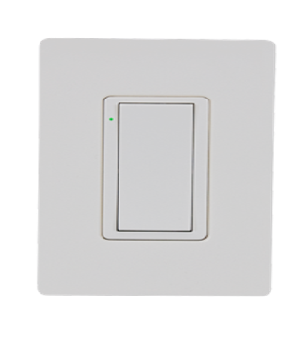
Product: Crestron ZUMMESH-KP10ABATT-W [B] [A]-S

4 Button (ON/SCENE 1/SCENE 2/OFF)

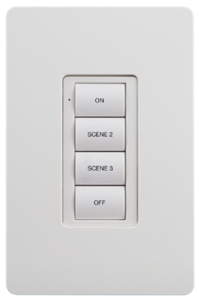
Product: Crestron ZUMMESH-KP10BBATT-W [B] [A]-S

6 Button (ON/SCENE 1/SCENE 2/OFF/DIM UP/DIM DOWN)

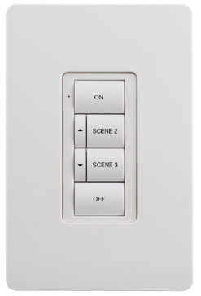
Product: Crestron ZUMMESH-KP10CBATT-W [B] [A]-S

6 Button (ON/SCENE 1/SENSOR DISABLE/OFF/DIM UP/DIM DOWN)

Sensor disable – lights will NOT turn off automatically for 2 hours

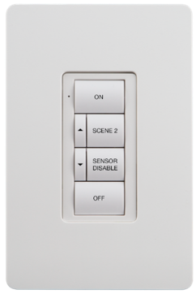
Product: Crestron ZUMMESH-KP10DBATT-W [B] [A]-S

Keypads (AC Powered)

Zūm MESH wireless communication

Box mountable

Trimmed using gangable Decorator trim plates

120 / 277 VAC input

Color shall be white [black] [almond]

1 Button (rocker with ON/OFF/DIM UP/DIM DOWN features)

Product: Crestron ZUMMESH-KP10A-W [B] [A]-S

4 Button (ON/SCENE 1/SCENE 2/OFF)

Product: Crestron ZUMMESH-KP10B-W [B] [A]-S

6 Button (ON/SCENE 1/SCENE 2/OFF/DIM UP/DIM DOWN)

Product: Crestron ZUMMESH-KP10C-W [B] [A]-S

6 Button (ON/SCENE 1/SENSOR DISABLE/OFF/DIM UP/DIM DOWN)

Sensor disable – lights will NOT turn off automatically for 2 hours

Product: Crestron ZUMMESH-KP10D-W [B] [A]-S

Open loop daylight sensors (Battery Powered)

Zūm MESH wireless communication

Utilizes open and closed loop technologies for auto calibration

Open loop sensing technology for daily sensing

Replaceable (2) lithium-ion AAA batteries (10-year life)

Product: Crestron ZUMMESH-PHOTOCELL-BATT

Motion Sensors

Zūm MESH wireless communication

Passive infrared sensing technology

Ceiling mounted

500 ft.² coverage (8-12 ft. ceilings)

Grace Occupancy – when lights turn off due to vacancy, a 15-second grace period starts during which the room lights can be turned on again by waving a hand to trigger the sensor.

Vacancy sensor shall go into occupancy mode when keypad low battery detected.

Replaceable lithium-ion 9V battery (10-year life)

Products:

Crestron ZUMMESH-IR-OCCUPANCY-BATT (auto on, auto off)

Crestron ZUMMESH-IR-VACANCY-BATT (manual on, auto off)

NETWORKING THE WIRELESS SPACES
SPECIFIER: Networking wireless spaces is OPTIONAL. Zūm is code compliant for most applications as stand alone Zūm MESH spaces. Networking the Zūm MESH spaces using Zūm NET technology adds features such as time clock, iOS app configuration, web browser maintenance, load shedding, and much more.

Wireless spaces shall be networked together to enable time clock, load shedding and global management features. The space shall be networked together using a Wi-Fi friendly 2.4 GHz mesh network topology. The range between the wireless devices shall be no more than 150’. The wireless technology shall be Crestron Zūm NET.

Networking the space shall incorporate BMS integration as specified hereto after.

Wireless solutions shall be fully compatible will all other lighting control solutions specified herein.

Wireless Bridge

Each wireless space shall have one wireless bridge. Linking the space (Crestron Zūm MESH) and the networking connection (Crestron Zūm NET).

Wireless bridge shall enable iOS app to reconfigure the space via Bluetooth technology.

Product: Crestron ZUMMESH-NETBRIDGE

Wireless Gateway

Crestron Zūm NET gateway shall have bi-directional MESH communication with up to 50 ZUMMESH-NETBRIDGE devices.

Powered via IEEE 802.3at Type 1

Product: Crestron ZUMNET-GATEWAY

Floor Hub

Connects up to 100 Crestron ZUMMESH-NETBRIDGE devices

Processor contains astronomical time clock

Maintenance is performed via standard web browser.

1 rack unit mounted

Product: Crestron ZUM-FLOOR-HUB

SPACE BUILDER

MANUFACTURERS

Basis-of-Design Manufacturer: Subject to compliance with requirements, provide products of Crestron Electronics, Inc., Rockleigh, NJ 07647, Phone (855) 644-7643, www.crestron.com [or comparable products from a single manufacturer approved by Architect prior to bidding], with the following components and characteristics.

Contractor shall provide the lighting control systems as called out herein and shown on the Contract Drawings with the following additional features

Each space shall be factory packaged with the load controller, keypads, sensors, and additional accessories necessary for a completely working space. There shall be separate containers for rough-in and trim materials. The box shall be labeled with the space type.

Each space shall be factory configured to operate when installed by the Contractor. On-site configuration shall only be required for sensor tuning and scene setting.

Each space shall be autonomous in its control and shall not rely on centralized processors for standard operations.

Products

Crestron SpaceBuilder GLPP

Crestron SpaceBuidler GLPAC

Crestron SpaceBuidler GLFLEX

Crestron SpaceBuidler GLDALI

Crestron SpaceBuidler GLDMX

Crestron SpaceBuidler GLGLIPAC

Crestron SpaceBuidler GLILUX

Crestron SpaceBuidler GLPYNG

Crestron SpaceBuidler GLPHASE

Crestron SpaceBuidler GLDIST

Crestron SpaceBuidler GLNET

1-3 ZONE LIGHTING CONTROLLER

MANUFACTURERS

Basis-of-Design Manufacturer: Subject to compliance with requirements, provide products of Crestron Electronics, Inc., Rockleigh, NJ 07647, Phone (855) 644-7643, www.crestron.com [or comparable products from a single manufacturer approved by Architect prior to bidding], with the following components and characteristics.

Provide 1, 2, or 3 zone lighting controller for switching or 0-10v zones. Unit shall operate as an autonomous lighting controller for the space. All sensors and zones within the space shall be controlled without the need for additional equipment.
SPECIFIER: replace above with comment below if networked GLPPs are required.

[Lighting controller shall be networked as part of the building wide lighting control system using Cresnet serial communication.]

Lighting controller shall be a surface-mounted industrial control enclosure mounts directly on two side by side 4” square electrical junction boxes, suitable for concealed locations. Lighting controller shall have flying leads with wing nut type connections.

Circuit Input: 100 – 277 VAC, 50/60 Hz. Input, one 16 amp

Zone Outputs

1, 2, or 3 high inrush mechanically held relays for switching loads

1,000,000 cycle mechanically latching relays

Zero-cross arc-less high inrush

Air gap off protection on each channel

0-10v dimming models shall include 0-10v 4 wiring dimming for each channel

Product

Crestron GLPP-SWCN (1 zone switching)

Crestron GLPP-1SW2CN (2 zones switching

Crestron GLPP-1SW3CN (3 zones switching

Crestron GLPP-DIMFLVCN-PM (1 zone 0-10v dimming with power monitoring)

Crestron GLPP-1DIMFLVCN2-PM (2 zones 0-10v dimming with power monitoring)

Crestron GLPP-1DIMFLVCN3-PM (3 zones 0-10v dimming with power monitoring)

GLPP SPECIFIC ACCESSORIES

Keypads

Connects to lighting controller with class II (2) #18 AWG or greater conductors.

Color shall be white [black] [almond].

Scene Functions

ROCKER (ON/OFF/hold to dim) or 4 Button (ON/SCENE 1/SCENE 2/OFF)

Product: Crestron GLPPA-KP-W [B] [A]-S

Zone Functions

Rocker controlling zone 1 (ON/OFF/hold to dim)

Product: Crestron GLPPA-KP1-W [B] [A]-S

Rocker controlling zone 2 (ON/OFF/hold to dim)

Product: Crestron GLPPA-KP2-W [B] [A]-S

Rocker controlling zone 3 (ON/OFF/hold to dim)

Product: Crestron GLPPA-KP3-W [B] [A]-S

4 Button controlling zones 1-3 (ZONE 1 toggle/ZONE 2 toggle/ZONE 3 toggle/OFF)

Product: Crestron GLPPA-KP4-W [B] [A]-S

[User Remote Control
SPECIFIER: This remote is optional.

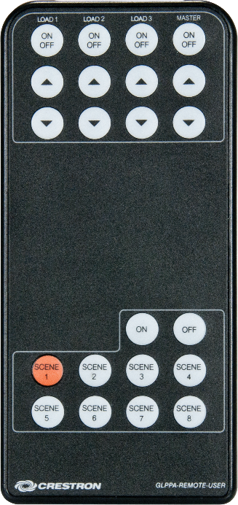
Lighting controller shall be adjustable using the handheld battery operated user unit.

Pre-programmed at factory, no configuration or programming required.

Remote shall provide features:

Zone control

Scene selection

Product: Crestron GLPPA-REMOTE-USER]

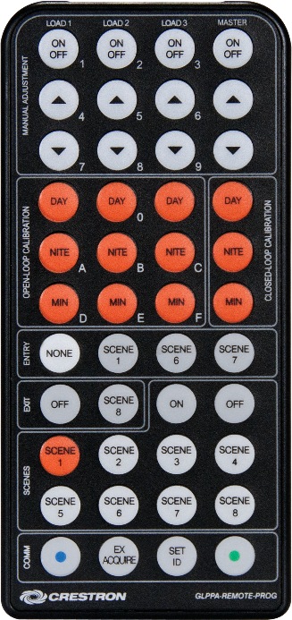
Configuration Remote Control

Lighting controller shall be adjustable using the handheld battery operated configuration remote.

Pre-programmed at factory, no configuration or programming required.

Remote shall provide features:

Zone control

Scene setting

Motion sensor mode select and timeout

Daylight sensor calibration

Provide minimum [1] configuration remote per project.

Product: Crestron GLPPA-REMOTE-PROG

Motion Sensors

Motion sensors shall be provided in spaces as shown on the Contract Drawings.

Dual technology ultrasonic and passive infrared motion sensing.

Lighting controller selectable occupancy (auto-on, auto off) and vacancy (manual-on, auto-off) modes.

Vacancy time out shall be adjustable

Equipped with 4-wire interface for direct connection to lighting controller enables IR handheld remote signals to be passed through the ceiling to the lighting controller.

Coverage: 360 deg., 2000 sq. ft

Ceiling or flush mounted

Color shall be white

Product: Crestron GLS-ODT-C-NS

4-8 ZONE LIGHTING CONTROLLER

MANUFACTURERS

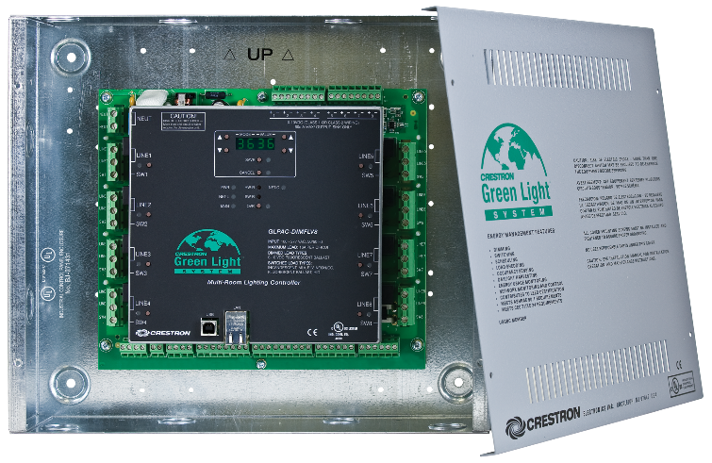
Basis-of-Design Manufacturer: Subject Smpliance with requirements, provide products of Crestron Electronics, Inc., Rockleigh, NJ 07647, Phone (855) 644-7643, www.crestron.com [or comparable products from a single manufacturer approved by Architect prior to bidding], with the following components and characteristics.

Provide 4 or 8 zone lighting controller for switching or 0-10v zones. Unit shall operate as an autonomous lighting controller for the space. All sensors and zones within the space shall be controlled without the need for additional equipment.
SPECIFIER: replace above with comment below if networked GLPACs are required.

[Lighting controller shall be networked as part of the building wide lighting control system using Ethernet communication.]

Lighting controller shall be a surface-mounted NEMA 1 industrial control enclosure, suitable for concealed locations.

4 or 8 circuit inputs

100 – 277 VAC, 50/60 Hz. 16amp each

[Barriered 4 normal and 4 emergency relays (-4E models only)]

4 or 8 zone outputs

100,000 cycle mechanically latching relays

Air gap off protection on each channel

0-10v 4-wiring dimming for each channel (60mA max current sink)

8 digital inputs

4 motion sensor inputs

4 daylight sensor inputs

Override port for UL924 life safety applications

[Real time power monitoring on all channels (-PM models only)]

[4 normally open isolated relays(-PM models only)]

[Chicago Plenum rated enclosure (-CP models only)]

Product

Crestron GLPAC-DIMFLV4 [-CP] [-PM] (4-CH controller)

Crestron GLPAC-DIMFLV8 [-CP] [-PM] (8-CH controller)

Crestron GLPAC-DIMFLV8-4E [-CP] [-PM] (4-CH normal & 4-CH emergency controller

CENTRALIZED PANEL SOLUTIONS

MANUFACTURERS

Basis-of-Design Manufacturer: Subject to compliance with requirements, provide products of Crestron Electronics, Inc., Rockleigh, NJ 07647, Phone (855) 644-7643, www.crestron.com [or comparable products from a single manufacturer approved by Architect prior to bidding], with the following components and characteristics.

PANEL CHARACTERISTICS

Panel shall be digitally addressable using serial or Ethernet communication from Control Processor Panel specified hereto after.

Lighting dimmers shall be compatible with drivers / ballasts and LEDs / lamps as listed in SS26 50 00 LIGHTING.

Dimmers shall be provided in quantities, control types, and rated for the connected load as shown on the Contract Drawings.

Line and load phases shall be coordinated per manufacturers recommendations.

Dimming modules shall be field replaceable.

Dimming panels shall be listed to UL508.

Lighting control panels shall be convection cooled without the use of moving parts.

Lightning Protection: can withstand 6 kV / 3 kA surge, as per IEC 61000-4-5 and ANSI/IEEE C62.41-1991

NEMA Type 1 enclosure, IP20 rated protection, for indoor use only; 16-gauge galvanized steel, surface wall mount; gray front cover with powder coated finish

Lighting control panels shall comply with NEMA PB 1 and UL 50 (CAN/CSA C22.2, No. 94), UL 67 (CSA C22.2, No. 29), UL 489 (CAN/CSA C22.2, No. 65), and UL 916 (CSA C22.2, No. 205).

FEED TYPES

Reference Contract Drawing schedules for required feed types and breaker ratings.

FEED-THROUGH (FT)

No branch circuit overcurrent protection.

Provide barriers as required to separate normal and emergency circuits in a single panel.

[Panels shall be fabricated as tub and tray. The tub shall be installable at time of rough-in while the factory wired tray is installed separately at time of trim.]

MAIN LUG ONLY (MLO)

120 VAC 3-phase; 120/240 VAC split-phase

20 amp thermal magnetic

AIC rated to 10,000A [22,000A] [65,000A]

Provide AFCI or GFCI where noted on Contract Drawings.

277 VAC 3-phase

20 amp thermal magnetic

AIC rated to 18,000A [35,000A] [65,000A]

MAIN CIRCUIT BREAKER (MCB)

120 VAC 3-pole

150 amp

200 amp

220 amp

AIC rated to 10,000A [100,000A]

277 VAC 3-pole

60 amp

80 amp

100 amp

125 amp

AIC rated to 18,000A [35,000A] [65,000A]

ZONE CONTROL MODULES

Standard switching

100,000 cycle mechanically latching relays

Air gap off protection on each channel

[Hi-Inrush Switching

1,000,000 cycle mechanically latching relays

Zero-cross arc-less high inrush

Air gap off protection on each channel]

[Modular Switching

Independently replaceable 20 amp mechanically latching relays

Single or double pole per Contract Drawings schedules

Air gap off protection on each channel

Product: Crestron GLR-HD-1P, GLR-HD-2P]

4-Wire 0-10v Dimming

Use for any 4-wire 0-10v dimming load

Zero-cross arc-less high inrush

Air gap off protection on each channel

2-Wire Phase Dimming

Universal Phase Dimming

Used for any 2-wire phase dimming loads.

Auto-load detection shall select forward- or reverse-phase control based on each channels load.

Zero-cross filtering to reduce lamp flickering

Air gap off protection on each channel

[Reverse Phase Dimming

Used for electronic low voltage (ELV) loads unless specifically noted otherwise or recommended by fixture manufacturer.

Reverse-phase dimming

Zero-cross filtering to reduce lamp flickering

Air gap off protection on each channel]

[Forward Phase Dimming

Used for magnetic low voltage (MLV) or incandescent loads unless specifically noted otherwise or recommended by fixture manufacturer.

Forward-phase dimming

Zero-cross filtering to reduce lamp flickering

Air gap off protection on each channel]

DALI SOLUTIONS

MANUFACTURERS

Basis-of-Design Manufacturer: Subject to compliance with requirements, provide products of Crestron Electronics, Inc., Rockleigh, NJ 07647, Phone (855) 644-7643, www.crestron.com [or comparable products from a single manufacturer approved by Architect prior to bidding], with the following components and characteristics.

Where indicated on the Contract Drawings, areas shall have all necessary parts, pieces and software for a fully turnkey DALI solution. System components shall comply with IEC 60929, Annex E, and IEC 62386 for DALI lighting control devices, wiring, computer hardware and software. Solution shall include but not be limited to:

Individually addressable electronic drivers/ballasts on the digital DALI bus. Drivers shall be able to receive commands and respond with status.

Sensors and user interfaces shall not reside on the DALI bus. These accessories shall be networked to the DALI interface controller as part of the turnkey solution. Reference specifications hereto after for more details on sensor and user interface selections that shall be compatible with the turnkey DALI solution.

The DALI bus shall be class 2 (1) twisted pair #18 AWG or larger and be shielded. Install in free air per DIV 26.
SPECIFIER: The DALI bus can be installed as class 1 or 2. Please select one. If selecting class 1, consider using 5 conductor MC cable and luminaire whips for clean installation.

[The DALI bus shall be class 1 (2) #12 THHN or larger and shall run with branch circuits in raceway per SS 26 05 33.]

Each space shall be configured to have a minimum (1) group for all luminaires, and (1) group for each zone of fixtures as shown on the drawings.

A DALI interface controller shall be provided

Interface shall control minimum (2) DALI loops (128 DALI addresses)

Contractor shall load the DALI loops to no more than 58 addresses at time of construction.

DIN 43880 form factor occupying not more than 9 DIN modules.

When replacing a single addressed luminaire, DALI re-addressing shall not require re-programming.

Mounts in NEMA 1 metal enclosure.

Product: Crestron DIN-EN

Override port shall open the DALI bus forcing all drivers/ballasts to emergency preset light level (100% ON).

DALI interface shall be commissionable from USB/Ethernet from a PC or from a lighting control touch screen. Software shall allow for configuration of driver properties, groups and scenes.

Product: Crestron DIN-DALI-2

DMX SOLUTIONS

MANUFACTURERS

Basis-of-Design Manufacturer: Subject to compliance with requirements, provide products of Crestron Electronics, Inc., Rockleigh, NJ 07647, Phone (855) 644-7643, www.crestron.com [or comparable products from a single manufacturer approved by Architect prior to bidding], with the following components and characteristics.

DMX Architectural Control

All Crestron series 2 or 3 processors shall support open DMX Ethernet.

DMX architectural control shall include color and intensity selection, preset saving/recall, and simple fade effects. Presets may be recalled from any user interface or triggered by astronomical time clock [or BMS event].

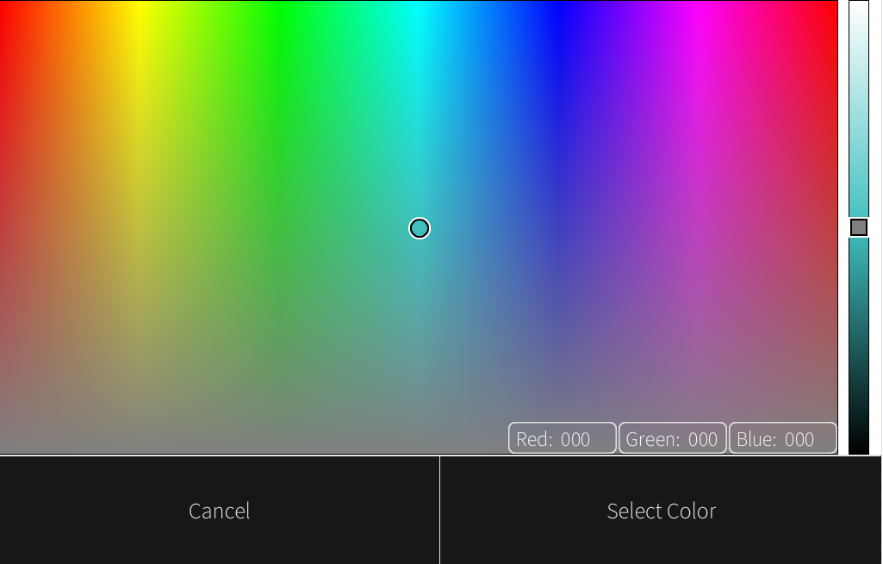
Touch screens specified hereto after and called out on the Contract Drawings shall have a color picker user interface. Interface shall accept graphical selections or numerical selections.

Adding zones of DMX controlled fixtures shall only require the addition of a DMX Ethernet converter.

Contractor shall provide DMX Ethernet converters as required to interface with architectural DMX zones as shown on the Contract Drawings.

sACN to DMX-512 Converter

Compatible with ESP and Art-Net DMX over Ethernet protocols.

Supports RDM bi-directional communication.

IEEE 802.3af PoE powered.

Single port DMX to Ethernet node that can be used in either input or output mode depending on software utility set up configuration.

Product: Crestron GLA-DIN-ODE-POE

DMX Show Control

Full DMX show control shall be provided for the following spaces:
SPECIFIER: Fill in any spaces within project that require full DMX show control.

[THEATER 101]

[Reference Contract Drawing plans for scope areas.]

The DMX Control Interface shall be a microprocessor based lighting system designed specifically as a multi-purpose lighting and show playback controller for entertainment and architectural applications. A personal computer running emulation software shall not be acceptable.

The DMX Control Interface shall be an integrated device that combines DMX-based lighting playback with architectural control features, scripting capability, and web-based control.

The DMX Control Interface shall store all of its programming data in non-volatile flash memory, including built-in flash memory and/or a removable flash memory card and can be transferred to/from a remote personal computer via Ethernet.

The DMX Control Interface shall have an internal real-time clock and calendar that operates from an internal lithium battery even in the absence of external power and be able to trigger shows and other events based on time of day, sunrise, sunset, day of week, day of year and/or a combination of these events.

The DMX Control Interface shall be capable of synchronizing its operation with and/or remotely controlling other DMX Control Interfaces of the same kind across an Ethernet network.

The DMX Control Interface shall support standard theatrical lighting playback models including direct channel control, fixture level control, groups, channel parking, scaling, disabling, offsets, transparency, tracking and overrides, which can be used to create submasters and grandmaster control, partitioning, zones and other control setups.

System capacity

The DMX Control Interface shall support:

Up to 2000 cues.

Up to 200 macros.

Up to 100 groups.

Up to 100 timer events.

Up to 500 timecode event triggers.

Up to 256 DMX input triggers.

Up to 512 button station buttons.

Up to 512 contact closures.

Up to 16 TCP/UDP packet triggers.

Reception of 512 DMX input levels.

Processing of 512 DMX output levels.

Additional DMX outputs may be supported by networking multiple DMX Control Interfaces together via Ethernet.

Product

Crestron GLA-DMX-1UNIVERSE (one 512 address DMX universe)

Crestron GLA-DMX-2UNIVERSE (two 512 address DMX universes)

USER INTERFACES

MANUFACTURERS

Basis-of-Design Manufacturer: Subject to compliance with requirements, provide products of Crestron Electronics, Inc., Rockleigh, NJ 07647, Phone (855) 644-7643, www.crestron.com [or comparable products from a single manufacturer approved by Architect prior to bidding], with the following components and characteristics.

KEYPADS

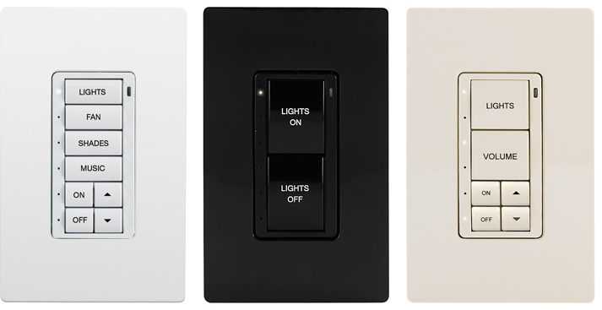
Provide keypad quantities and locations as specified herein and shown on the Contract Drawings.

Field-configurable remote keypad with auto-adjusting backlight illuminating replaceable, engraveable programmable buttons in number indicated, with white LED indicators, configured to fit in standard single-gang box.

Trimmed using decorator face plates.

Cresnet connected for power and communication

Maximum buttons: 8

Color shall be white [black] [almond].
Additional colors and finishes are available, visit http://www.crestron.com/products/model/C2N-CBD-P for more information.

Product: Crestron C2N-CBD-P-W [B] [A]-S

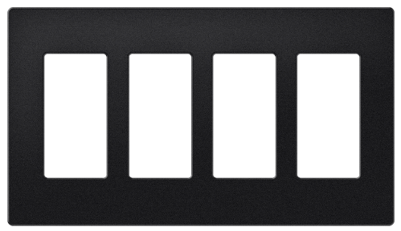
FACE PLATES

Provide decorator faceplates for all keypad devices.

Multiple devices adjacent to door jams shall be ganged together.

Decorator faceplates shall be white [black] [almond] and shall match in texture and color the keypad devices.
Textured, metal and additional colors are available at http://www.crestron.com

Product

FP-G1-W [B] [A]-S (1 gang faceplate)

FP-G2-W [B] [A]-S (2 gang faceplate)

FP-G3-W [B] [A]-S (3 gang faceplate)

FP-G4-W [B] [A]-S (4 gang faceplate)

TOUCH SCREENS

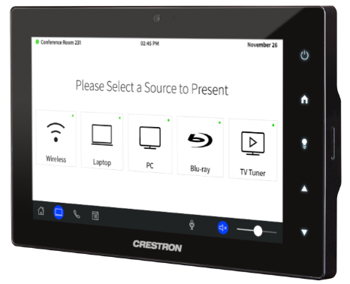
TFT active-matrix color LCD touch screen

Projected capacitive, 5-point multi-touch technology

24-bit 16.7M colors, and dual-window HD video, HDTV, and high-resolution RGB streaming multimedia, IP intercom, and web browsing capabilities. Dynamic graphics and text capability. Enables custom control screen programming.

5 hard keys pushbuttons

Bidirectional 10/100 Mbps Ethernet communication.

H.264 and MJPEG streaming video.

5.0 MP camera

Built-in microphone and speaker with multi-language voice recognition

Rava SIP intercom

Connected via IEEE 802.3af Class 3 PoE Powered Device

Surface mount over 2-gang or 3-gang electrical box.

Color: [Black] [White].
Models are available without camera or microphone. Visit http://www.crestron.com/products/model/TSW-760

Products

Crestron TSW-760-W-S (7” white, 2-gang mounted)

Crestron TSW-1060-W-S (10” white, 3-gang mounted)

Crestron TSW-760-B-S (7” black, 2-gang mounted)

Crestron TSW-1060-B-S (10” black, 3-gang mounted)

XPanel Interface: Virtual Touch Screen

Touch screen user interface, network-connected lighting management interface running on Crestron lighting control processor to provide lighting control, daylight harvesting, occupancy sensing, lighting schedules and overall adjustment to system functionality

Virtual touch screen is to be accessible via computer or laptop interface furnished by other.

Access to XPanel shall be via browser based IP address or .EXE file application.

Product: Crestron XPANEL

SENSORS

MANUFACTURERS

Basis-of-Design Manufacturer: Subject to compliance with requirements, provide products of Crestron Electronics, Inc., Rockleigh, NJ 07647, Phone (855) 644-7643, www.crestron.com [or comparable products from a single manufacturer approved by Architect prior to bidding], with the following components and characteristics.

Contractor shall provide quantities and locations of sensors per the Contract Drawings and as required for turnkey commercial lighting control operation.

MOTION SENSORS

Dual-Technology Ceiling Mounted (networked)

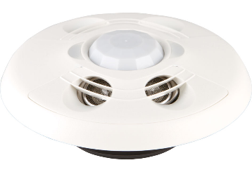
Detects movement within space while reducing false triggering or shutoffs while space is occupied. Combination of ultrasonic motion detection and passive infrared detection with internal microprocessor. Sensitivity is independently adjustable for installed conditions. Delayed time off adjustment. Walk-through mode.

Equipped with 4-wire interface for direct connection to control bus.

Includes connection port for remotely mounted photocell.

Coverage: 360 deg., 2000 ft.²

Set-up and commissioning parameters shall be configurable via a handheld wireless remote.

Mounts to 3” octagon box

Product: Crestron GLS-ODT-C-CN

Dual Technology Wall Mounted

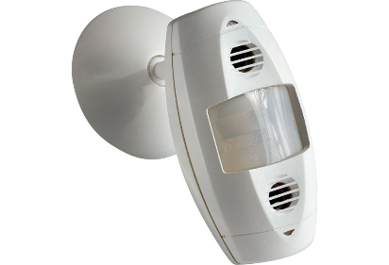
Detects movement within space while reducing false triggering or shutoffs while space is occupied. Combination of ultrasonic motion detection and passive infrared detection with internal microprocessor. Sensitivity is independently adjustable for installed conditions. Delayed time off adjustment. Walk-through mode.

Equipped with 3-wire interface for direct connection to control system utilizing control processor

Coverage: 110 deg horizontal., 1200 ft.²

Mounts to 4” octagon box or surface mounted.

Product: Crestron GLS-ODT-W-1200

DAYLIGHT SENSORS

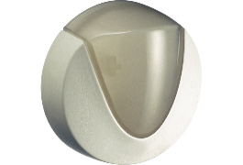
Indoor Daylight Sensor (open loop)

Continually monitors daylight entering window or skylight to enable daylight harvesting applications to provide control of room lighting based on presence of daylight. Equipped with 3-wire interface for direct connection to control system utilizing control processor; 24 VDC power from network control bus.

Light sensitivity: 3 to 6,000 foot-candles

Mounting: [Ceiling flush mounted] [Ceiling surface mounted] [Wall flush mounted] [Wall surface mounted] [As indicated].

Product: Crestron GLS-LOL

Indoor Daylight Sensor (closed loop)

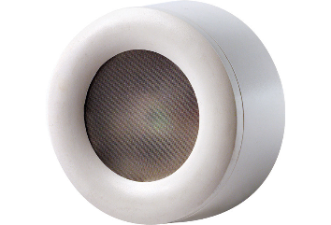
Continually monitors daylight at work station location to enable daylight harvesting or lumen maintenance applications to provide control of room lighting based on lighting level at workstation. Equipped with 3-wire interface for direct connection to control system utilizing control processor; 24 VDC power from network control bus.

Light sensitivity: 0 to 70 foot-candles

Mounting: [Ceiling flush mounted] [Ceiling surface mounted] [Wall flush mounted] [Wall surface mounted] [As indicated].

Product: Crestron GLS-LCL

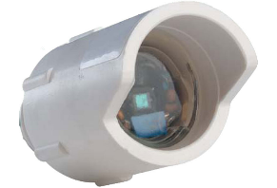
Exterior Daylight Sensor

Sensor shall continually monitor the total ambient light level and can adjust the lighting as necessary to reach the desired light level. The sensitivity is adjustable so that a 10V signal matches full daylight and 0V matches total darkness. A built in visor provides more consistent readings by blocking direct sunlight, and also protects the lens from the elements.

Sensor shall be installed facing north.

Light Sensitivity: 5 to 750 foot-candles

Power: 24 VDC

Mounting: surface mount

Product: Crestron GLS-LEXT

PARTITION SENSORS

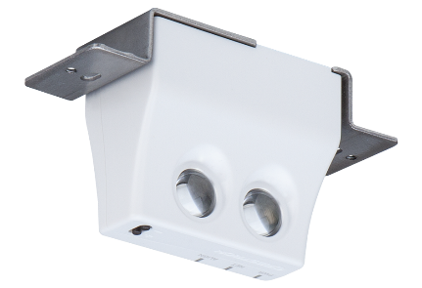
Single sided diffuse reflective sensing technology.

Digital device with control bus connectivity.

Surface mounted to 1-gang back box.

Trim using decorator face plate to match mounting surface

Product: Crestron GLS-PART-CN

SENSOR INTERFACE MODULE

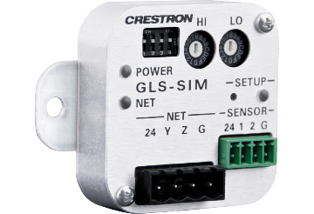
Sensor Interface Device: Integrates occupancy sensors and related sensors with control network. In separate enclosure. 4-wire bus providing 24 VDC power to network devices, with two independent sensing inputs.

Product: Crestron GLS-SIM

CONTROL PROCESSOR PANEL

Manufacturers

Basis-of-Design Manufacturer: Subject to compliance with requirements, provide products of Crestron Electronics, Inc., Rockleigh, NJ 07647, Phone (855) 644-7643, www.crestron.com [or comparable products from a single manufacturer approved by Architect prior to bidding], with the following components and characteristics.

Control Processor Panels shall be provided in quantities and locations per the Contract Drawings, or as required for a fully networked lighting control system.

Control Processor Panels shall be factory assembled in a UL508 panelshop.

Shall include but not be limited to the following equipment to support all lighting control devices.

Cabinets

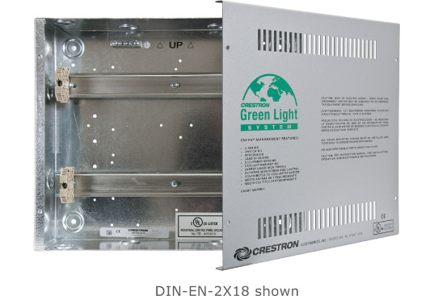
Cabinet shall be made of 16-gauge galvanized steel

NEMA 1 rated

All DIN rails and mounting accessories shall be furnished an properly installed.

Product: Crestron DIN-EN

Processors

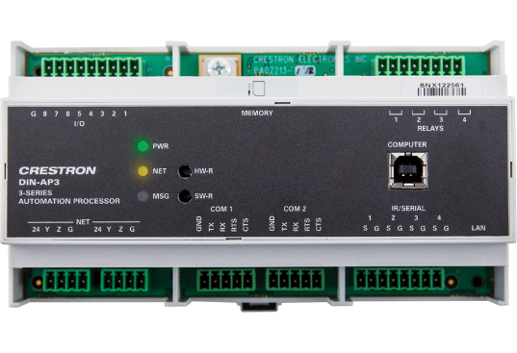
Crestron 3-series control system

Modular architecture supports multiple simultaneous running programs.

Ethernet 10/100Base-T and Cresnet connected

Astronomical time clock with events stored in non-volatile RAM

Native BACnet/IP with support for up to 500 BACnet objects

Built-In Web Server: IIS v.6.0

SNMP remote management.

Active Directory support.

IPv6 ready.

DHCP and DNS Support

Native Email Client

Remote Diagnostics

Remote Program Loading and Administration

SSL security plug in

Support user assigned or dynamic IP address.

Products

Crestron DIN-AP3

Crestron RMC3

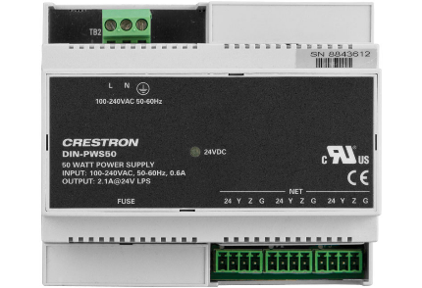
Power Supplies

Provide regulated 24 VDC power supplies as required to support lighting control equipment.

120 VAC input

Product: Crestron DIN-PWS50

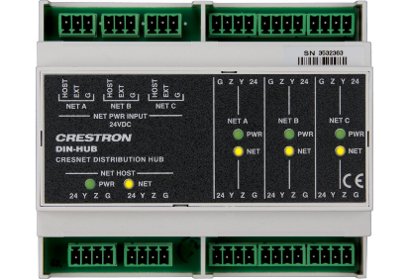
Hubs

Provide Cresnet distribution hubs as required to support all Cresnet devices.

Product: Crestron DIN-HUB

UL924 EMERGENCY OVERRIDE

Automatic Load Control Relays (ALCR)

0-10v Loads

UL924 listed 4-wire automatic load control relay shall bring life safety lights on to 100% on loss of power.

120/277 VAC

Product: Crestron GLA-EPC-FLV

Switched Loads

UL924 listed 2-wire automatic load control relay shall bring life safety lights on to 100% on loss of power.

Products

Crestron GLA-EPC-P-120 (120 VAC)

Crestron GLA-EPC-P-277 (277 VAC)

Emergency Shunt Relays (ESR)

2 or 3 Wire Phase Controlled Loads

UL924 listed 2/3-wire emergency shunt relay shall bring life safety lights on to 100% on loss of power.

Products

Crestron GLA-ESR-120-3/4 (120 VAC)

Crestron GLA-ESR-277-3/4 (277 VAC)

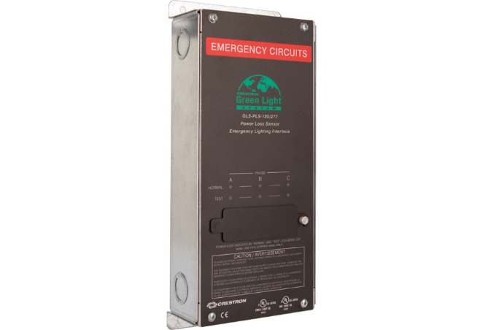
Phase Loss Sensor

Lighting control panels shown on the Contract Drawings as emergency life safety shall have override UL924 listed override ports.

Provide 3-phase loss sensor fed with normal power. Upon loss of any phase the phase loss sensor shall trip the emergency lighting control panel override port(s).

Product: Crestron GLS-PLS-120/277

PROGRAMMING AND CONFIGURATION SOFTWARE

Lighting system configuration software shall allow custom programming of embedded operating systems for control of lighting system.

Lighting system configuration software shall Provide a graphical symbol based programming and development environment.

The Lighting System Configuration software shall generate Custom Software Control Interface Modules for communication with compatible remote integrated systems.

The Custom Software Control Interface shall include the following control data:

Complete lighting system control functions.

System specific control sets for sub systems and supervisory systems.

The Custom Software Control Interface shall be capable of communicating the following data types:

Bidirectional digital and analog data communication.

Bidirectional serial data communication.

CONDUCTORS AND CABLING

Power Supply Side of Remote-Control Power Sources: Comply with requirements of Division 26 Section "Low-Voltage Electrical Power Conductors."

UTP Cable: 100-ohm, UTP. Listed and labeled by an NRTL acceptable to authorities having jurisdiction as complying with UL 444 and NFPA 70 for the following types:

Communications Control Cable, Non-Plenum Rated: 22 AWG data pair stranded bare copper, and 18 AWG power pair stranded bare copper, Type CM.

Product: Crestron CRESNET-NP.

Communications Control Cable, Plenum Rated: 22 AWG data pair, stranded bare copper and 18 AWG power pair, stranded bare copper, Type CMP, complying with NFPA 262.

Product: Crestron CRESNET-P.

Communications High-Power Control Cable, Non-Plenum Rated: 22 AWG stranded bare copper data pair, and 12 AWG stranded bare copper power pair, Type CM.

Product: Crestron CRESNET-HP-NP.

EXECUTION

FIXTURE TESTING

Contractor shall provide lighting control factory test reports for each fixture specified on this project.

Fixtures already tested and listed in the factory database do not require re-testing.

Test report shall include:

Confirmation of compatibility with control device

Dimming Range

Performance notations

Crestron factory fixture compatibility testing information may be found here: http://www.crestron.com/resources/lighting-fixture-compatibility

TUNABLE WHITE CONTROL
SPECIFIER: DALI or DMX drivers should be selected for tunable white fixtures. Be sure to specify coordination meetings as required for properly operating tunable white control. Please contact Crestron for more information (855) 644-7643.

Tunable white fixtures as specified in SS 26 50 00 and shown on the contract drawings shall have DALI [DMX] drivers and controls as specified hereto before.

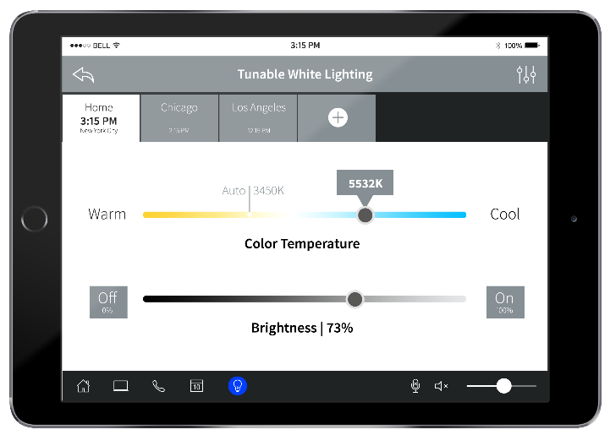
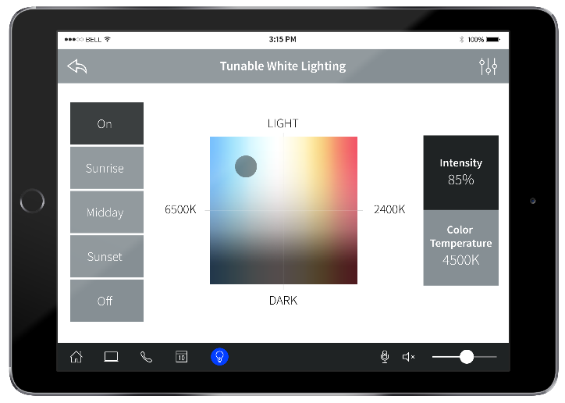
Touch screens specified hereto after and called out on the Contract Drawings shall have intensity and color temperature controls as well as a color picker user interface.

Meetings shall occur between the Owner, Contractor, and Manufacturer to coordinate the sequencing and features of the tunable white fixtures. Tunable white coordination meetings shall include but not be limited to:

[(2) 2 hour]

[(2) 8 hour on-site visits]

PLUG LOAD CONTROL

Plug load controls as shown on the Contract Drawing shall be part of the lighting control system.

Plug loads shall operate in a Occupancy MODE. Auto-ON and Auto-OFF.

ENGRAVING

Keypad buttons shall be factory engraved using laser technology.

Initial shipment of keypads shall be factory engraved per the sequence of operations specified herein and shown on the Contract Drawings.

Custom keypad engravings shall be provided as part of the close out procedures.

BMS INTEGRATION

The lighting control system shall be integrated with the BMS system as specified in Division 25.

Communication shall occur using BACnet/IP.
Contact Crestron at 855-644-7643 for integration to other BMS systems.

Contractor shall provide licenses for each the following objects shall be shared with the BMS system:

Occupancy Status

Zone On/Off/Dim

Photocell reading

The lighting control system shall also accept time clocked events from the BMS system.

Provide necessary coordination labor for integration of all BACnet objects listed hereto before.

AV INTEGRATION

The lighting control system shall be integrated with the AV solutions as specified in Division 26.

The lighting and AV systems shall interface via Ethernet communication.

Contractor shall provide Ethernet drops as required for the lighting control system to talk to the AV solutions.

The following objects shall be shared with the AV system:

Occupancy Status

Zone On/Off/Dim

Photocell reading

Scene preset recalls

Provide necessary coordination labor for integration of all AV objects listed hereto before.

SYSTEM FUNCTIONS AND SEQUENCES

System Control Functions: The system shall be capable of the following lighting control functions:

Scene Creation: store levels of selected fixture circuits in preset groups.

Scene Recall: recall previously stored scenes.

Off: all zones off.

Dim up/down: raise/lower level of all zones.

Password Entry: enter password to enable touch screen control access.

Room/Zone Selection: select room, zone or area to be controlled.

Shade Control: raise or lower room shades.

Event Scheduler: select times for scenes to be automatically recalled.

USER INTERFACE CONTROL FUNCTIONS

The Keypad interface shall be capable of the following system control functions:

Scene Recall

Off

Dim up/down

Touch Screen and Virtual Touch Screen: Touch Screen and Virtual Touch Screen interfaces shall be capable of the following system control functions:

Password Entry

Multiple levels

Room/Zone Selection

Scene Recall

Dim up/down

Shade Control

Scene Recall

Event Scheduler

Customer logo and color scheme

Optional Control Sequences for Advanced Control:

Occupancy adjustments

Timeout

Control logic (occupancy or vacancy sensor)

Lighting Scenes

Custom scene adjustment through sliders and press+hold operation

Individual zone control override

Timeclock Adjustment

Modify timeclock activation schedule

Select/unselect pre-programmed timeclock events

Display all timeclock events

Daylight Harvesting Adjustments

Minimum dim level

Response time

Zone control

Scene Recall

Fade time

Color scene recall and saving

TIME CLOCK EVENTS

The lighting control system shall have astronomical time clocked events. 6 time clock events shall be provided.

End User shall have the option to create additional time clock events via touch screen or XPanel interfaces

INSTALLATION

Prior to installation, examine work area to verify measurements, and that commencing installation complies with manufacturer's requirements.

Comply with requirements of Division 26 Sections "Common Work Results for Electrical."

Do not install network power controls until space is enclosed, HVAC systems are running, and overhead and wet work in space are complete.

Install network power switching controls in accordance with manufacturer's instructions.

Grounding: Provide electrical grounding in accordance with NFPA 70.

MANUFACTURER SUPPORTED SERVICES

PRE-WIRE

Manufacturer shall provide on-site visit during the rough-in stage of the installation. At this time wiring topologies and terminations shall be reviewed with the Contractor.

STARTUP

Provide manufacturer's system startup and adjustment.

Switch each load on and off with manual line test feature of the power switching module before installing processors.

Perform operational testing to verify compliance with Specifications. Adjust as required.

TUNING

Within 12 months of the date of Substantial Completion provide onsite service to adjust the system to account for actual occupied conditions.

TRAINING

Factory authorized service representative to instruct owner's staff to adjust, operate and maintain network power switching systems; and provide instruction using the system software.

Demonstration: Schedule demonstration with Owner.

Training: Train Owner's personnel to operate, maintain, and program network power switching systems. Allow for a minimum of trips to the jobsite to provide additional training as needed.

Furnish set of approved submittals, and record drawings of actual installation for Owner's personnel in attendance at training session.

  - END OF SECTION
  - 26 09 43

